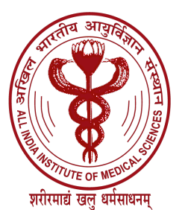

ALL INDIA INSTITUTE OF MEDICAL SCIENCES

EXAMINATION SECTION

F.No.AIIMS/ExamSec/Ph.D/10-27/2020 Dated: 26.11.2020

RESULT NOTIFICATION NO. 141 / 2020

The following candidate who appeared in the Public Defence and Viva-voce Examination for Ph.D. held on 17.11.2020 has been declared successful:

SR. NO. | NAME | DEPARTMENT
1. | Ms. Shanky Garg | Pharmacology

Sd/-

[(DR. ASHOK KUMAR JARYAL)
ASSOCIATE-DEAN (EXAMS)

